**Teach Kids to Set the Table in 5 Simple Steps**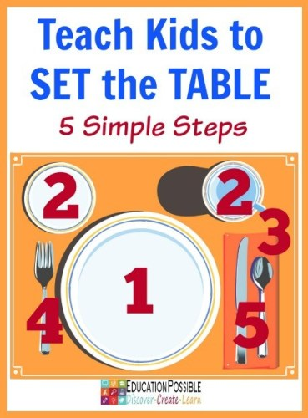

**Materials:**

* 1 dinner plate
* 1 bread plate (optional)
* 1 drinking cup
* 1 napkin
* 1 fork
* 1 spoon
* 1 table knife (use a child-friendly knife)

Take a few minutes to show each piece of tableware to your child and make sure they know the proper name for each item.

Have your child sit or stand by the dinner table so they can place the pieces in the correct spot for their own table setting.

Begin by setting the pieces to the side. Pick up and hand each item to your child as you describe the 5 steps.  During each step your child will place the appropriate item in the correct location on the table.Report this ad

**Set the Table in 5 Simple Steps**

**#1 Dinner Plate**

Place the big plate in the middle, directly in front of you.

**#2 Bread Plate (this is optional) and Drinking Cup**

Place the bread plate (optional) on the left-hand side of the plate and the cup on the right-hand side. Refer to the picture above.

***USEFUL TIP:*** *For this step you will place 2 items on the table, one on each side of the dinner plate.  Ask your child to put both of their hands in front of them and then join the tips of their index fingers and thumbs together on each hand to make circles. Put their remaining fingers together and point them straight up.*

*Ask your child – “Which lower case letters do your fingers make?”*

*The* ***left hand*** *looks like a lower case b. Bread plate starts with a “b” so it will be placed to the top left of the dinner plate.*

*The* ***right hand*** *looks like a lower case d. Drinking cup starts with a “d” s it will be placed to the top right of the dinner plate.*

[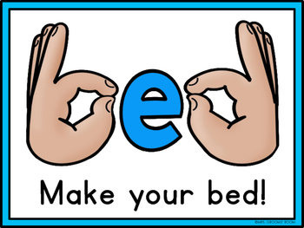](https://www.google.com/url?sa=i&url=https%3A%2F%2Fwww.teacherspayteachers.com%2FProduct%2FB-D-REVERSALS-2390950&psig=AOvVaw3g1_FoIDBD5ycN4hw6Ava_&ust=1588942946160000&source=images&cd=vfe&ved=0CAIQjRxqFwoTCLCH-snooekCFQAAAAAdAAAAABAI)

Report this ad

**#3 Napkin**

The napkin can be placed to the right of the dinner plate. (refer to the picture above)

**#4 Fork**

Place the fork on the left side of the dinner plate.

**#5 Spoon and Knife**

Place the spoon and knife on the right side of the dinner plate (refer to the picture above).There was an error submitting your subscription. Please try again.

**Clearing Own Dishes after a Meal** 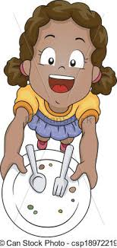

1. Stand up

2. Place silverware and napkin on plate or in bowl

3. Pick up plate or bowl, with silverware and napkin on top

4. Carry plate or bowl without spilling, with silverware and napkin on top, to kitchen sink area

5. Put plate or bowl on counter near kitchen sink

6. Return to the spot where the child was sitting at the table

7. Pick up cup or glass

8. Carry cup or glass to kitchen sink area

9. Put cup/glass on counter near the kitchen

(PIRS Team: Barbara Berger, Susan Monfet, Janice Torres, Simone Smith)